**Robotic Process Automation**

UiPath-Document Understanding (Purchase Order and Invoice Data Extraction)

Technical Flow Document

Document History

|  |  |  |  |  |  |
| --- | --- | --- | --- | --- | --- |
| Date | Version | Role | Name | Organization  Department | Comments |
| 06-03-2024 | 1.0 | RPA Developer | Dhiraj Patil | Cybermeru | Document Created |

Document Flow

|  |  |  |  |  |  |
| --- | --- | --- | --- | --- | --- |
| ***Version*** | **Flow** | **Role** | **Name** | **Organization (Dept.)** | **Signature and Date:** |
| ***1.0*** | **Document prepared by:** | *Manager* | *Piyush Kulkarni* | *Cybermeru Technologies* |  |
| ***1.0*** | **Document Studied by:** |  |  |  |  |

Contents

Table of Contents

1. Introduction 4

1.1. Purpose of the Document 4

**1.2.** **Objectives** 4

1.3. Minimum Prerequisites for Automation 4

1.4. Assumptions 5

2. As-IS Process Flow 6

2.1. Process Overview 6

2.2. Feature Used in the Process 7

2.3. As-Is Process Map (Technical Flow) 8

2.4 Detailed As-Is Process Steps 9

3. Description 19

3.1. Input Data Detail 19

3.2. Output Data Expected 19

## Introduction

## Purpose of the Document

The Technical Flow Document is created for every business process that is automated using the RPA technology. The document needs to be reviewed and updated for every change requested and applied to the automation process. This document will provide a technical snapshot and must always reflect the latest design and key features of the automated workflow.

The document naming convention will follow the naming convention and the version of the automated process. This can be “business process name version” or it can be defined, case by case, as part of the larger RPA project design. Solution design document includes:

* Business and technical requirements regarding the project as provided by the end-user .
* High-level design approach
* Solution design in terms of a BPM flow
* Data flow diagram describing the technical solution.
* List of discrete services/activities that are orchestrated in the flow.

## **Objectives**

About Process automation required cause process is followed every day and having repetitive task. In the process there are some steps to complete a task. In this process, receive input data in project input folder and data have some documents like Purchase order and some are Invoices. Next step is to read each document one by one in sequence.

After that is require to extract some data from the current reading document and fill that data in the excel report file. If current reading document is Purchase order extract data and fill that data in ‘PO Details’ Excel file sheet same for Invoices fill in ‘Invoice Details’, so like that by reading each document by manually extract data from document and fill in excel report require to maintain excel report file.

At last once extraction is completed for all files, the last step is to send a report file to a specific person on mail.

## Minimum Prerequisites for Automation

1. Standard Machine to run automation.
2. UiPath Studio Installed in machine.
3. Actual live data to support development.

## Assumptions

1. **Stable Process Environment:** The process environment will remain stable without frequent changes during the development and execution of the RPA solution.
2. **Consistent Input Data:** Input data provided to the automated process will be consistent in format and structure. Any variations or changes in data will be handled within the defined scope.
3. **Access Permissions:** The RPA bot will have the necessary permissions to access required systems, applications, and data sources. Any changes in access permissions will be communicated and addressed promptly.
4. **System Availability:** Systems and applications involved in the process will be available and accessible as per the defined schedule. Any planned downtimes or maintenance windows will be communicated in advance.
5. **Network Stability:** The network infrastructure will be stable, ensuring reliable communication between the RPA bot and the integrated systems. Any potential network issues will be promptly resolved.
6. **Error Handling:** The error handling mechanisms defined in the RPA solution will effectively address common errors and exceptions. Unforeseen errors will be documented and addressed during maintenance.
7. **User Input Consistency:** If human intervention is required at any stage of the automated process, users will provide input consistently as per the defined instructions. Variations in user input will be handled within the designed error-handling framework.
8. **Data Security Compliance:** The data processed by the RPA bot will comply with relevant data security and privacy regulations. Any changes in data security policies will be addressed and implemented accordingly.
9. **Third-Party Integration Stability:** Integration points with third-party systems or services will remain stable. Any changes in APIs or endpoints will be communicated in advance, and necessary adjustments will be made to the RPA solution.
10. **Documentation Accuracy:** The information provided in the existing documentation (such as process manuals, flowcharts, etc.) is accurate and up-to-date. Any discrepancies will be identified and resolved during the development phase.

## As-IS Process Flow

## 2.1. Process Overview

General information about the process selected for RPA prior to automation.

|  |  |  |
| --- | --- | --- |
| Sr No | Item | Description |
| 1 | **Process full name** | UiPath-Document Understanding  (Purchase Order and Invoice Data Extraction) |
| 2 | **Process Area** | Documentation |
| 3 | **Department(s)** | Billing, Purchase |
| 4 | **Process short description**  **(operation, activity, outcome)** | This process useful to Extract data from input document and write extracted data in excel report file, at last send report file on mail to specific person. |
| 5 | **Input Data** | From Project Input Folder. |
| 6 | Output Data | Excel report file in output folder and shared report file on mail. |

## 2.2. Feature Used in the Process

The table includes a comprehensive list of all the features that are used as part of the process automated, at various steps in the flow.

|  |  |  |
| --- | --- | --- |
| **Sr No** | **Feature Name** | **Comments** |
| **1** | UiPath Studio | UiPath Studio is advanced automation software that helpful to Develop Automation code. |
| **2** | UiPath Orchestrator | Orchestrator is a web-based tool for monitoring & managing automation, it’s a centralized platform for managing software robot |
| **3** | UiPath Document Understanding | Document understanding is feature of UiPath useful to extract details from the any type of documents. |
| **4** | UiPath Document OCR | It is a technology that recognizes text within a digital image. It is commonly used to recognize text in scanned documents and images. |
| **5** | Generative AI Extractor | Generative AI Extractor useful in data extraction from the documents by prompting, it has self-understanding and extract require text. |
| **6** | Machine Learning Extractor | Machine Learning Extractor useful in data extraction from the documents by using algorithms & patterns that learn from data to make prediction result give require text. |

## 2.3. As-Is Process Map (Technical Flow)

## 2.4 Detailed As-Is Process Steps

Below are the steps using that Robot (Automated Laptop & Machine) will be extracted Data from documents:

**Step-1: Load Taxonomy (Initializing project structure and setting)**

A software application works with data, which is generally modeled as entities (or objects, or tables in a database) with fields (or columns). Similarly, in the DU universe, this data model is called a **taxonomy**, and it models the type of documents that the project will work with.  Basically it is creation of structure where we can classify document according to their category, Create require extracting fields from document and we call that structure in automation for execution of process. It is hierarchical in structure as shown:

**Ex.** As Shown in picture structure is like Document Input is main branch and this main branch have two sub-branches as A) Billing & B) Purchase consider this are department in organization. These two Sub-Branches have specific documents Billing have invoices & Purchase have Purchase Orders. In structure from each document there are fields that require extract from documents as shown in above picture.

**Step-2: Read Input files from folder.**

After loading taxonomy structure robot will fetch all documents path from input folder.

Then pass each document in ‘for each loop’ for process documents on by one for data extraction.

**Step-3: Digitization of Document.**

Here Robot will do digitization for current processing documents means that converting image, scanned PDFs into a useful and readable text. Using OCR technology robot will get useful text from document.

**UiPath Document OCR:**   OCR "Optical Character Recognition." It is a technology that recognizes text within a digital image. It is commonly used to recognize text in scanned documents and images. The **UiPath Document OCR** is optimized for usage on scanned documents and images of documents, result give all useful text from document so robot can work on that text in next steps.

**Step-4: Classification of Document.**

There are two different types of documents in taxonomy invoice and PO, Robot will understand document by converted text from OCR and classify document for further processing.

In this step robot will classify current processing document either is Invoice or Purchase order by using passed keywords in keyword classifier as shown below. Robot will find that keyword in converted text from document.

**Step-5: Data Extraction From Document.**

Next step Robot will extract data from document using extractor like A] Generative AI for Invoice B] Machine Learning for PO. Robot will Extract Data using Generative AI (By Prompting), Machine Learning Algorithm and Using OCR

Applied on document as per their best performance in data extraction for that specific document. (we can use any extractor for any document for better output)

Here robot will extract data for require fields that we created in taxonomy structure, we get data for fields:

**Invoice Fields Purchase Order Fields**

1. Invoice Number 1) PO Number
2. Due Date 2) PO Date
3. Billed To 3) Customer Date
4. Amount Due 4) Total Amount

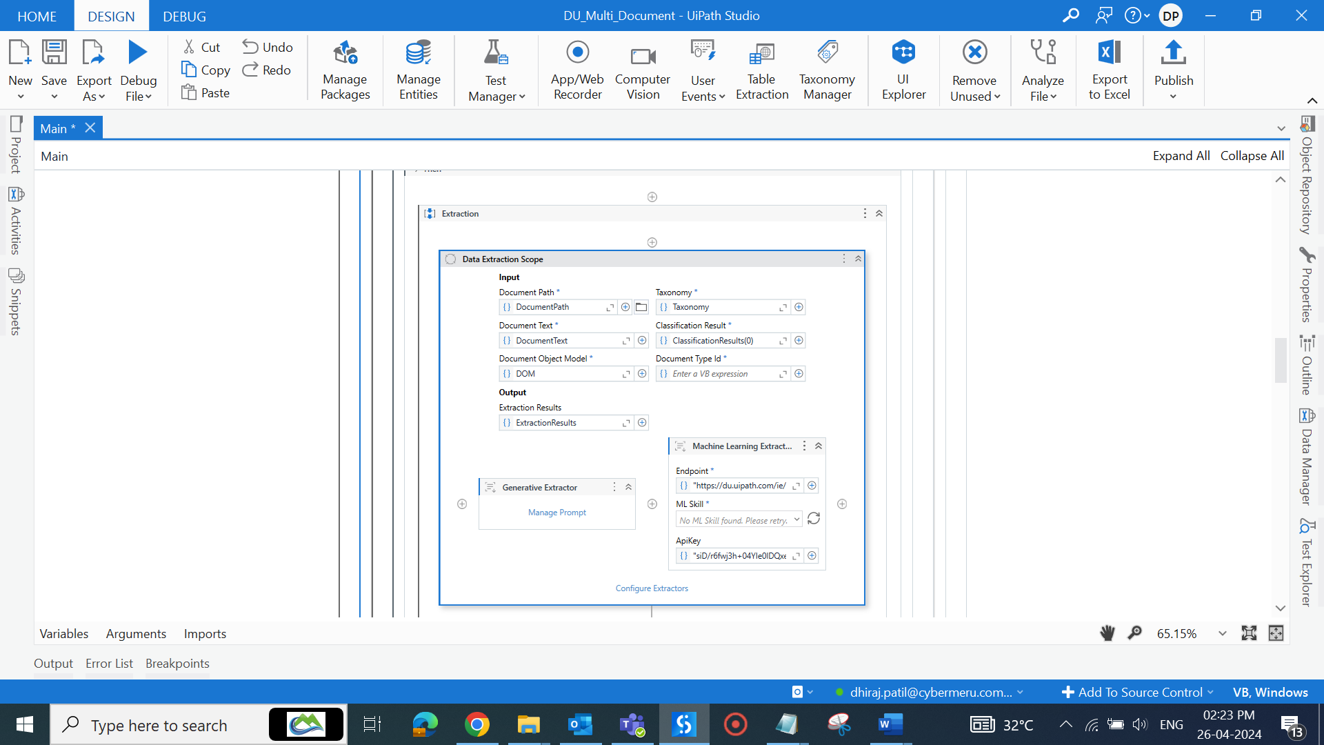

**Generative Extractor:** Allows you to extract documents using generative models. The Generative Extractor can extract text from documents as defined in the Taxonomy Manager.

Generative means self-creator so robot will extract the required fields from document by self-understanding. It is like a Chat GPT, we ask a question to Chat GPT and GPT will give us answer in result. Same as Generative extractor will give require filed from converted text that we get from OCR.

We will get results by prompting (Asking question to robot) using the Manage Prompt Wizard.

The manage prompt wizard allows you to select a document type and a field, and an optional value to define the prompt. The prompt is used to identify the fields to be extracted, provided as key-value pairs, where the key represents the name of the field and the value a description for it, helping the extractor identify the corresponding value.

Here Generative extractor is enabled for invoice documents. As shown above picture, we can understand how extractor call require data with Key-Value pair, so here we get keys from taxonomy structure and values are getting by prompting.

**For ex.**

Key - Amount Due (Getting from taxonomy structure)

Value - (Prompt:- Total amount in invoice with currency symbol)

Result will get data at execution time example as **$ 2850**

**Machine Learning Extractor:** Enables data extraction from documents using [machine learning models](https://docs.uipath.com/document-understanding/docs/overview-ml-packages) provided by UiPath. Machine learning extractor extract data by using data and algorithms to enable AI to imitate the way that humans learn, gradually improving its accuracy.

Machine learning extractors are predefined and trained extractors that were developed by UiPath for data extraction. We just require using it by passing Endpoint (URL to use ML skill for data extraction) And API key (we get it from UiPath orchestrator).

ML Extractor apply, trained algorithms and patterns for data extraction on the converted text that is getting from OCR. Every Purchase order has some fixed values like PO Number, PO Date, PO amount, Customer Name etc. so ML extractor can easily extract require fields from document using algorithms, behind ML Extractor there have huge amount of data, which is helpful to achieve desire result, in configure extractor wizard we can get automatic fields just by-passing endpoint (URL) in extractor as shown in below image. We only need select field which value we want from dropdown.

**Step-6: Validate Extracted Data**

After Extraction of data from document, if require human can involve in automation for extracted data validation, by checking checkboxes human can verify data.

If Current Processing Document is Purchase Order validation require to do as shown:

If Current Processing Document is invoice validation require to do as shown:

**Step-7: Export Result**

Next step is after validation robot will store that current processing document result in data table. If its purchase order will store result in PO data table, for invoice will store in Invoice data table.

After this stage bot will again fetch next document for processing. Once all input documents are processed, robot will write all stored data in output excel report file available in output folder.

**PO data in Po details Sheet Invoice data in Invoice details Sheet**

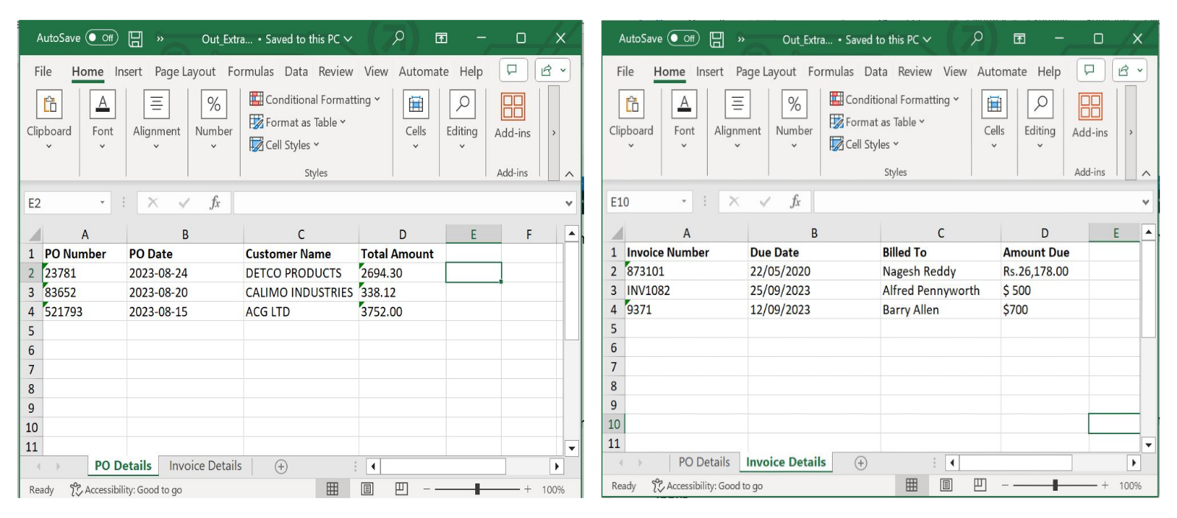

**Step-8: Send Report on Mail.**

Last step is bot will fetch prepared excel report file path from project output folder to send this file on mail to specific person.

Share file on mail as shown below:

## Description

## 3.1. Input Data Detail

* Details for the folders that will contain the necessary inputs as well outputs for the entire process including the log files.
* Naming convention for the files.

Input

1. Robot (Automated Laptop or Machine) will take the input from the Project Input folder.

## Output Data Expected

Output

1. Robot will write data in Excel file after extraction completed for all documents in project Output folder.